T2425.32 Teys Road Culvert Upgrade

Question 1: Location of culverts to be supplied by client?

Response: It is 2km from the site to the storage location on Tognolini Baldwin Drive. The coordinates of the site are as follows: <https://maps.app.goo.gl/KiSjJQi4iPy12oP17>

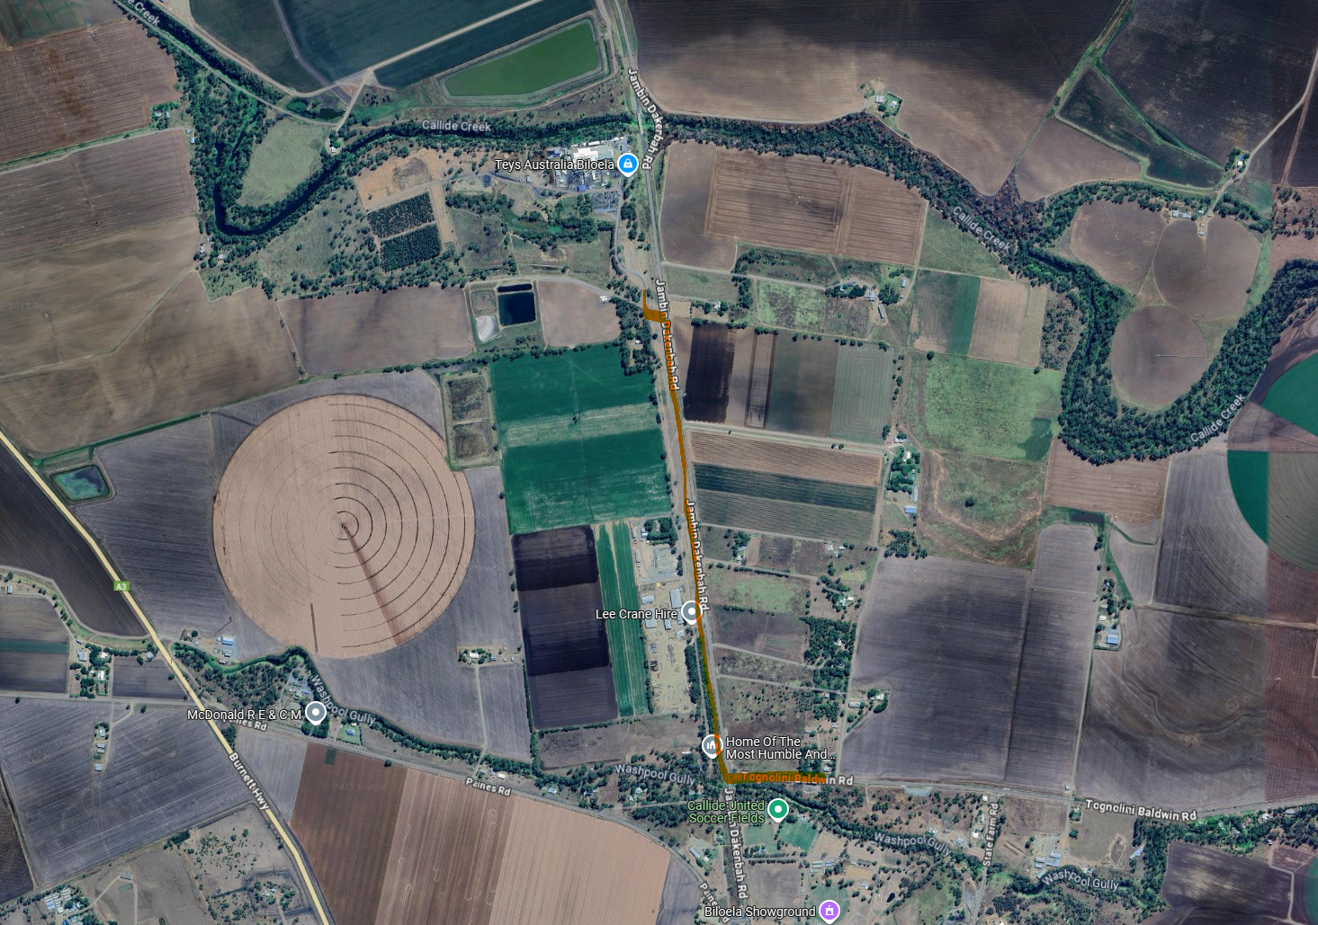

Question 2: Can a copy of the side track plan be provided?

Response: Please find attached a copy of the side-track plans.

Question 3: Is there a TGS that relates to the side track?

Response: There is no current TGS for the side-track. A TMP/TGS will need to be created and implemented to manage vehicles using the side-track and inform motorists on Jambin Dakenba Road of the new conflict location, potentially including a speed reduction for the vehicles on the through-road.

Question 4: When will the side track be completed?

Response: The sidetrack should be completed the week commencing 28 April 2025