Minor Tender – Leasing of Commercial Shed (Site of 1C Dawson Highway, Biloela)
Tender T2425.35
_____________________________________________________________________________

Supplier Details:

Business Name | ABN
Trading Name
Contact Person | Phone
Email Address

Scope :
Banana Shire Council has 1,116m² of commercial land in Biloela available for rent. The land compromises of a commercial shed divided into 2 areas, and an undercover area located at 1C Dawson Highway, Biloela. Pursuant to section 227 of the Local Government regulation 2012 Banana Shire Council is inviting tenders for a term of three years with annual rental review and ability to renew the lease term for another two terms (subject to negotiation).
The tenders could be submitted by completing this form and attaching the public liability insurance.

Description of Property:
This site is currently zoned as ‘Community Facilities – Precinct 5’ in Council’s Planning Scheme 2021.

A development application would be required for use of the site for activities that are not accepted in the Community Facilities Zone. Depending on the planned business activity an approval may not be required.

The site is fully fenced. There is vehicle access to the property via the laneway off Dawson Highway. The shed features internal and external power outlets and internal lighting. Access to toilet amenities may be arranged.

Site grounds-keeping including mowing, will be completed by Council (included in monthly lease fee).

Criteria
Public liability insurance of $20 million is a requirement for using this site, please submit your current Certificate of Currency with your submission.

Electricity costs will be payable by the lessee.

Your submission must also nominate a rental figure. The final rental figure will be determined by negotiation between Council and the successful applicant.

Site visits can be arranged by contacting the Principal Land and Lease Management Coordinator on 07 4992 9500.
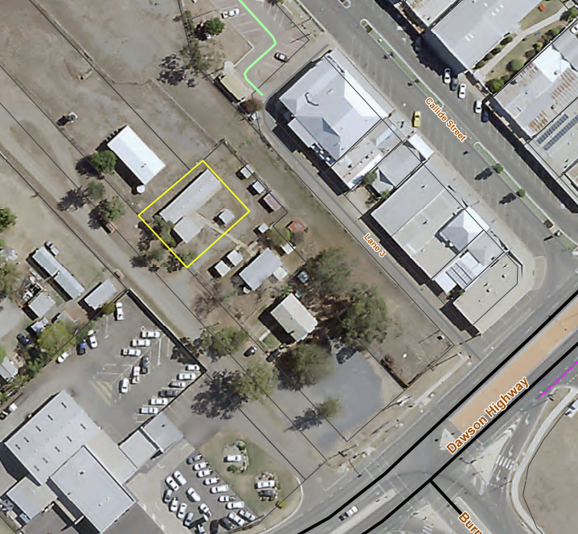

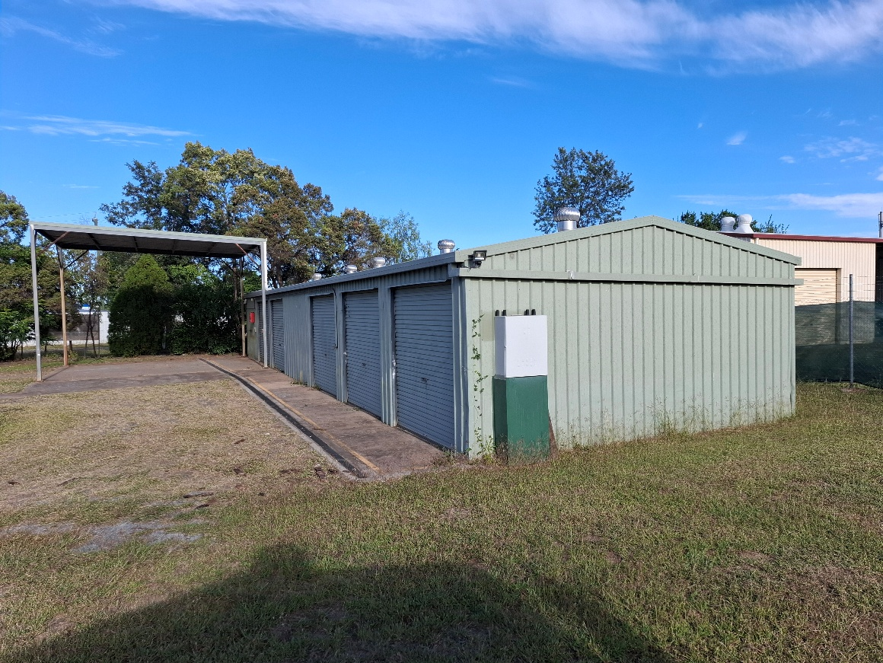

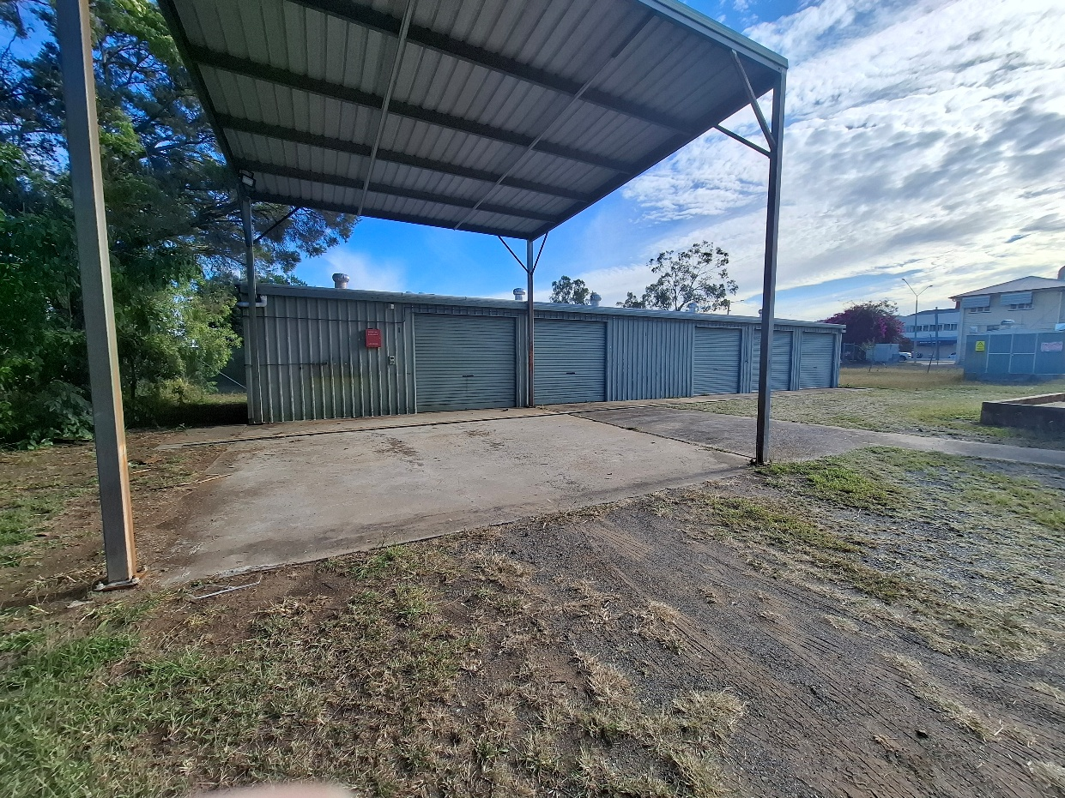

Tender submission deadline
3.00 pm, Monday, 23 June 2025

Submission Information:
☐ Submit all required documentation as required in the evaluation criteria and rental scope

Evaluation criteria

Criteria | Weightage
Price/Value for money – Does the submission state a rental figure acceptable to Council? | 40%
Economic value generated to the community from the lease | 50%
Evidence of Work Health and Safety Policy & Incident Reporting Procedures | 10%

Tender Submission
Detail the rental rate per week you are willing to offer (ex gst) for year 1…….year 2……Year 3……

Describe the business activity that you intend to use the lease …………………………………………………….

Other Comments:

Conflict of Interest | Please advise if you have an association or connection to current members of staff.  ☐ YES ☐ NO  If yes, please indicate persons you have an association with:
By signing this form, you acknowledge that you have provided the correct information and are willing to be contacted about your submission.

Signature |  | Date

To ensure your tender is processed accurately and in a timely manner please adhere to the following:

- ONLY SUBMIT BY EMAIL to tenders@banana.qld.gov.au. Tenders received by paper or emailed to a different email will not be accepted.
- Provide all required documentation e.g., Insurance, forms, schedules etc.
Acceptance of Tender:

- Council is not obliged to accept the lowest, or any submission, and may accept the submission most advantageous to it.
- Council reserves the right to award the EOI in accordance with Council’s Procurement Policy & Procedure.
- No tender shall be taken as accepted and no contract will be formed, until the supplier signs a rental agreement with Council.
Submissions and enquiries by email to tenders@banana.qld.gov.au or to speak to a representative, please call 07 4992 9500.

Please use Tender T2425.35 as reference in all correspondence.

