ENVIRONMENTAL DESKTOP AND SITE ASSESSMENT

The aim of the assessment is to identify environmental aspects associated with a project to ensure legislative obligations are met. Mitigation measures are then incorporated into the design, environmental management plan (EMP), site induction, and approvals are gained if required.
The assessment consists of two phases. Part 1 - Desktop environmental assessment, and Part 2 – On site environmental assessment.
Replace writing in italics with your own text. Where an element is not applicable, provide an explanation why it is not.
Project details
Project title / no. | Jambin Goovigen Road Floodways W8899
Desktop assessor(s) | Samantha O’Brien | Desktop assessment date | 30/06/2025
Description of works
Chainage 3450:
Replacement of damaged concrete.
Chainage 9960-10125:
Rehabilitation of existing roadway pavement, rebuilding existing floodway, extending length, excavation of table drain and install rock protection.
Associated documents
Design Plans for Chainage 9960-10125

Be aware of the full scope of works. Clarify uncertainties before undertaking the assessment.
Become familiar with Queensland Globe (Q Globe) identification layers before you start by using the Help Section and Tutorial Videos. Please contact the Environmental Sustainability Team (ES Team) for further assistance.

Desktop environmental assessment

Location
Identify | Details | Source
Lot on plan | NA | Queensland Geocoder  Q Globe ‘Search’, ‘Land parcels’ layer
Latitude and longitude | CH 3450  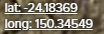  CH 9960-10125  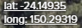 | Q Globe (bottom left of screen, relates to curser point)
Road name and Chainage | Jambin Goovigen Road  CH 3450  CH 9960-10125 | KIM
Land tenure/ easements/ reserve | Road parcel | Q Globe ‘Land parcels’, ‘Land parcel tenure’, ‘Lease and reserve parcel’ layer

Watercourses and wetlands
Element/aspect | Details | Requirement/source
Watercourses and waterbodies inside and within 50m of the site boundary | Unnamed Watercourse – Minor Intermittent at Chainage 10045  Neville Creek – Minor Intermittent at Chainage 3485 | Q Globe ‘Watercourse’ and ‘Watercourse (defined by Water Act 2000)’
Removal of vegetation from, excavating or placing fill into a watercourse, lake or spring | Minor regrowth vegetation for removal if required during excavation – 1m deep at rock work | Department of Local Government, Water and Volunteer’s Riverine protection permit requirements.  Contact ES Team to check project meets exemption requirements
Wetland trigger area | NA | Q Globe ‘Wetland protection area’, ‘Trigger area’.  Contact ES Team if works within 200m of a wetland

Cultural heritage and Native Title
Task | Details | Requirement/source
Cultural heritage and Native Title assessment | Referred 30.06.25  MagiQ ID#1970664 | Follow cultural heritage and native title procedures and assessment

Sensitive receptors – dust, noise and vibration, light
Identify | Details | Requirement/source
Sensitive receptors for dust | Residences >700m from site  Travelling Public | Q Globe ‘Land use’
Sensitive receptors – sensitive land uses for noise and vibration | Residences >700m from site  Travelling Public | Q Globe ‘Land use’
Sensitive receptors – critical facilities, infrastructure and utilities for noise and vibration | Reports saved to file.  Telstra assets identified in search area for both locations. | Check Before You Dig Australia (BYDA) (registered infrastructure services/pipelines).  Identify services not shown on the BYDA e.g., some pipelines, fibre optics lines, water mains, sewers (some of these are on KIM).  Q Globe ‘Land parcels’ and ‘Petroleum pipeline licence centrelines (ppl)’

Contaminated land
Identify | Details | Source
Asbestos containing materials | Not in a Water or Sewer Retic area. | Where the site is in a sewered and/or reticulated water area, check KIM for the presence of asbestos (AC) pipes and pits
Contaminated Land Register (CLR) / Environmental Management Register (EMR) | Not listed on CLR/EMR

Flora and fauna
Element | Details | Requirement/source
Regulated vegetation | Saved to file.  Category B & R  Map included below | Department of Resources Vegetation map or property report (save to file).  Use the Vegetation Management Report if there is a lot on plan number or use the Regulated Vegetation Management Map if only have coordinates
Vegetation clearing / Exempt clearing | Vegetation Management Act 1999 | List of exempt clearing work under the Vegetation Management framework,
Significant regional ecosystems / protected areas | Saved to file. | Environmental Reports online tool – Regional ecosystems report (save to file)
Protected plants and animals (threatened, near threatened, and special least concern species) | Saved to file.  At risk species shown below. | Queensland Government WildNet database – Request a species list for a specified point, set by central coordinates, distance 5 km (or to cover whole linear project plus 2 km each side), for all species, native, any status, all records and dates.  A high-risk species management program may be required where threatened species animal breeding places are on the list and identified during a site visit.  ES Team to consider if the project triggers state or federal referral for matters of environmental significance
Protected plants high-risk trigger area | Saved to file.  Not in trigger area, but site closet to Goovigen is in close proximity to green zone. | Department of Environment, Science and Innovation Protected plants flora survey trigger map – save to file (maps only valid for 12 months). Entire project disturbance area must be covered.  A flora survey by an ecologist is required for disturbance in a trigger area, few exemptions apply.  Allow several months for survey and approvals.  Refer to DES-EM-32-007 Requirements for Clearing Protected (Native) Plants under the Nature Conservation Act 1992 Work Instruction
Waterway barrier works | Unnamed Watercourse – Red (High) at Chainage 10045  Work Type 2.1  Neville Creek – Purple (Major) at Chainage 3485  Work Type 2.1 | Q Globe ‘QLD waterways for waterway barrier works’.  Business Queensland Waterway barrier works website, and Accepted development requirements for operational work that is constructing or raising waterway barrier works.  Pre and post works notification to the administering authority (Department of Primary Industries (DPI)) is required for compliance with the ADR.  A development application is required where the ADR are not met.  Refer to the Working in Watercourses Environmental Procedure (EXEC-PP-PRO-045)

Biosecurity
Identify | Details | Source
Expected weed / pest species | Species List saved to file. | Queensland Government Environmental Reports online tool – Weed list report, or WildNet database – Request a species list for a specified point, set by central coordinates, distance 5 km (or to cover whole linear project plus 2 km each side), for all species, introduced, any status, all and more recent records (save to file).  Review or print DPI fact sheets for Prohibited invasive plants and Restricted invasive plants for site visit
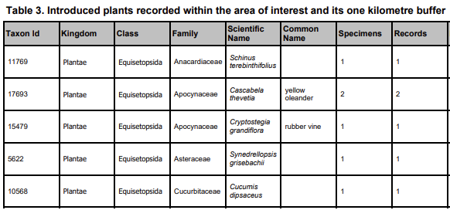

Sourcing of construction materials
Identify | Details | Requirement/source
Water take | Biloela Standpipe | Water sourcing will be conducted in accordance with the Department of Regional Development, Manufacturing and Water’s (DRDMW) Exemption requirements for constructing authorities for the take of water without a water entitlement (OSW/2020/5467)  Refer to Water Take for Constructing Authorities Work Instruction (DES-EM-32-002) and Infrastructure Services’ Water Take Point Notification Spreadsheet and KIM Layer.
Quarry materials | Commercial Quarry | The Forestry Quarry Management Plan (DES-EM-06-001) is to be followed where extraction is from an Endorsed Quarry Area under sales permits

Maps and plans
Protected Plants Trigger Map
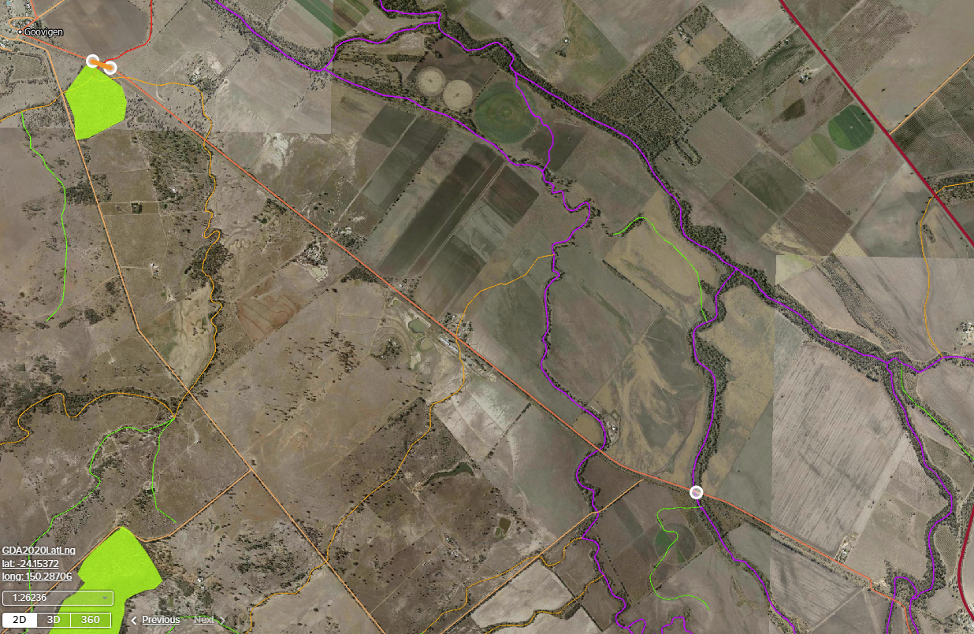
Regulated Vegetation Map
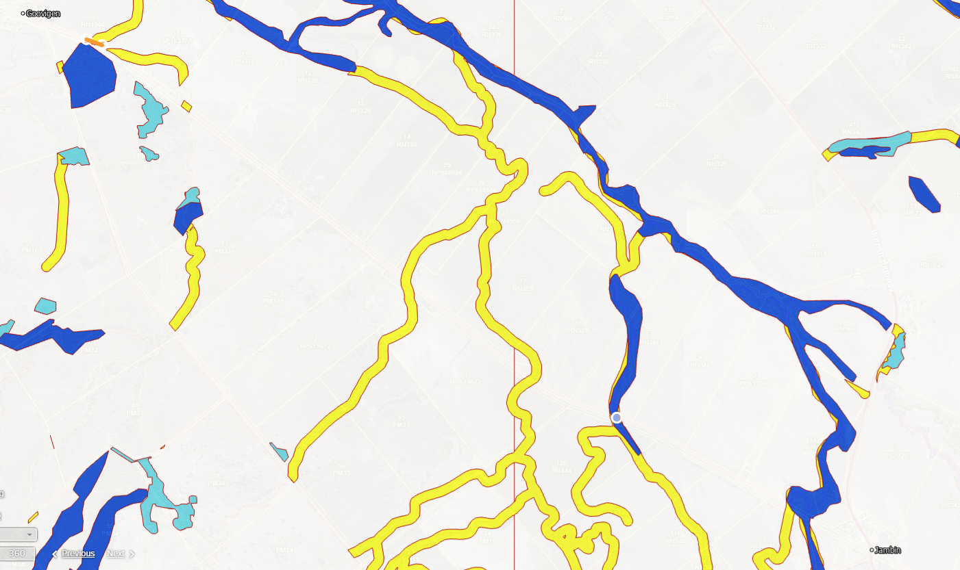

On site environmental assessment
Site assessor(s) | Cathy Collins | Site visit date | 04/08/2025
Take photos of all elements for evidence and potential inclusion in the EMP (e.g., animal breeding places, invasive weeds, habitat trees, waste and erosion).

Flora and fauna
Identify | Details | Purpose/follow up
Protected animals, their breeding places and habitat | Three large trees at chainage 3500 RHS, potential animal breeding places.  Additional onsite assessment may be required if these trees are to be removed.  A spotter/catcher to be engaged as part of clearing activities. | The ES Team is to be consulted where works are likely to interact with actual or potential animal breeding places.  A suitably qualified and experienced person (licenced spotter/catcher) must be engaged if tampering with breeding places (damage, destroy, mark, move or dig up).  A high-risk species management program may be required where special least concern, endangered, threatened or near threatened species/animal breeding places are on the list and identified during a site visit. EMP update will also be required.  Refer to the Protected (Native) Animal Breeding Places and Species Management Program Procedure
Habitat trees | Refer to above comment regarding the habitat trees. | Discuss with project team to retain explore possibilities of modification to project to retain habitat trees.  Exclusion barriers (mesh) to be erected around significant vegetation that is to be retained.  Vehicles are not to be parked under driplines of vegetation that is to be retained
Protected plants | No protected plants identified within the disturbance area.. | If these species are present, requirements exist. Refer to DES-EM-32-007 Requirements for Clearing Protected (Native) Plants under the Nature Conservation Act 1992 Work Instruction Contact the ES Team for assistance.  Mapped high risk trigger areas will already require a flora survey and clearing permit.  Allow several months for survey and approvals

Biosecurity
Identify | Details | Source, purpose/follow up
Evidence of prohibited or restricted weeds or pests | Mother of millions  Harrisia cactus | Contact Land Protection Officers for management advice prior to commencing works

Erosion and sedimentation
Identify | Details | Source, purpose/follow up
Erosion areas | Low risk erosion potential.  Use of core logs and silt fences to be used where appropriate. | Visual evidence of erosion/rills or potential problem areas.  For erosion and sediment control considerations and site-specific information, refer to the Erosion and Sediment Control Plan.  Discuss with ES Team if severe erosion is present

Contamination and waste
Identify | Details | Source, purpose/follow up
Waste produced from the site | Spoil, concrete, concrete washout residuals. | Contact Waste Services for disposal advice.  Discuss potential reuse of materials with Infrastructure Services

Sourcing of construction materials
Identify | Details | Source, purpose/follow up
Water take point | Biloela standpipe. | Ensure compliance with DRDMW Exemption requirements for constructing authorities for the take of water without a water entitlement (OSW/2020/5467) – 25% of depth available for take.  If a new water take point is proposed, notification to DLGWV required no less than 10 business days prior to take

Suitable locations for stockpiles, parking, storage
Identify | Details | Source, purpose/follow up
Material stockpiles, chemical storage areas etc. within 50m of a watercourse | Limited information. | ES Team to discuss adequate environmental protection measures with Project Coordinator/Supervisor

Site set up
Identify suitable sites away from sensitive areas (e.g. protected plants trigger or essential habitat mapped areas, watercourses, noise sensitive receptors) for ancillary activities.  Add to site map/diagram | Consider sites for:  - Stockpile sites  - Turnaround points  - Construction water  - Material sources  - Waste disposal  - Chemical and fuel storage  - Site office  - Parking locations  - Access and side tracks  - Borrow pits  - Concrete washout

Improvement opportunities
Environmental improvement opportunities at the site
(List any potential opportunities to improve the condition of the environment at the site/from the project or reduce the disturbance footprint)

