**Notice to Tenderers No:** 2

Banana Shire Council (BSC) has received a query with respect to the Tender. The following has been reviewed:

**Additional Information**

Banana Shire Council has identified and updated the following information:

***Council would like pricing for two options for Site 2. The pricing schedule to reflect the alternate option for lightly bound is provided.***

***Option 1 – As per Site 1 Detail (2 x layers lightly bound pavement import material)***

***Option 2 – Detail 3 Below (1 x Layer lightly bound insitu material with provisional corrector top up, Type 2.1)***

***Regarding methodology, Option 2 (Detail 3) top up if required could be placed on top existing pavement & blended into existing pavement. Existing road pavement and top up reclaimed to a depth of 200mm + top up (if used) depth with stabilizing agent. Compaction, trimming, curing to follow matching existing levels.***

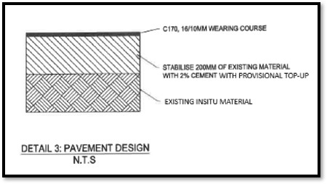

***Naming convention has been changed to reflect lightly bound pavement type in schedules.***

**Also, amended pricing schedule attached - Appendix C - Pricing Schedule _ Jambin Goovigen Floodway - V2**

Moreover, the original closing date was **11:00 a.m. on September 26, 2025, but it has been extended to 11:00 a.m. on October 01, 2025**.

Tenders shall be prepared in accordance with the tendering conditions available from the Council. The Tender documents are to be received at the Banana Shire Council Administration Complex, located at 62 Valentine Plains Road, Biloela, by **11:00 a.m. on October 01, 2025.**

Tender documents can be obtained by accessing [www.banana.qld.gov.au](http://www.banana.qld.gov.au) – Tenders and Quotes.

**Tender Submission**

Tender responses and attachments will be accepted via email submission to [tenders@banana.qld.gov.au](mailto:tenders@banana.qld.gov.au) or via Dropbox. Hard Copies are not required.

**Dated: 25th September 2025**